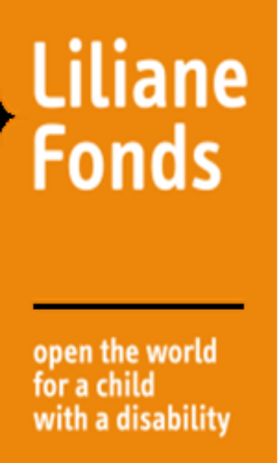
1. Applicant Information (1 page)

Name of Organization
Project Title
Name & Title of Head of organization
Contact address
Email Address(es)
Phone Number(s)
Years of existence?
No. of paid staff
No. of Volunteers
List of similar projects executed; amount and sources of funds

2. Project Summary (2-3 pages)

Project title
Thematic focus
(Education, Health, Livelihoods)
Location of project
(State, LGAs, Communities)
Project Duration in months
i. Specific problem to be solved:

ii. Goal and objectives of the project with clear targets:

iii. List and explain all activities to be implemented in the project:

iv. List and explain all expected outcomes of the Project:

v. Identify number of direct and indirect beneficiaries of the Project:

vi. Identify key stakeholders from government and the beneficiary community and explain how they will be involved in the project:

vii. How will the project be sustained when the grant ends? (Projects without clear sustainability plans will not be funded):

3. Financial Summary (1-2 pages) State all figures in NGN

Total Cost of project
Amount requested from TLMN/LF (Max 95%)
State other sources of funding (Max 5%)
Total organizational budget in 2021

4. Risk Management (1 page)

Potential Risk | Probability of Occurrence | Possible Impact on Project | Mitigation Strategies

5. Monitoring & Reviews (Half page)

State how you and other stakeholders will monitor and learn from the project?:

6. Any other Relevant Information (Half page)

State any other relevant information on the project:

